
K4 CSF3133 REKA BENTUK ANTARA MUKA BERASASKAN WEB
SEM 3
LAB REPORT 4

PREPARED FOR:
ASSOC. PROF. TS. DR. WAN NURAL JWAHIR
LAB ASSISTANT:
MISS WAN FATIN

PREPARED BY:
WAN NUR SYAFIQAH IZANI BINTI WAN HIZHAN
NO. MATRIC: S75776
SUBMIT BY: 22/10/2025

Lab 4 – Cascading Style Sheets (CSS) Part 1

4.2 Page Structure Elements
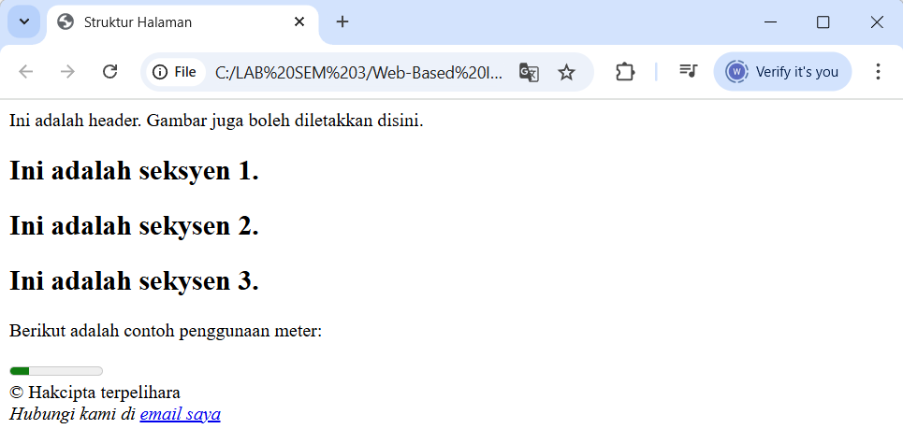

4.3 Insert Video into HTML5 Document
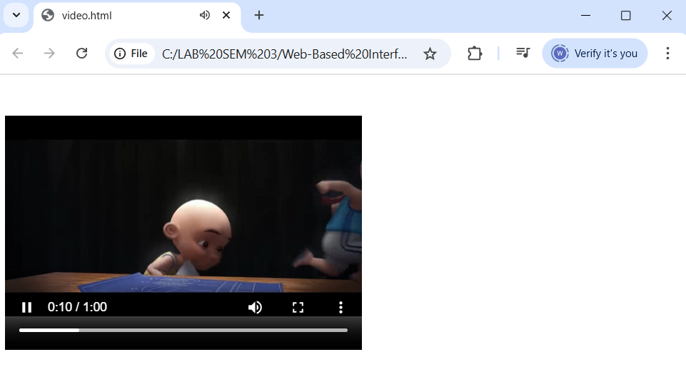

4.4 Cascading Style Sheets
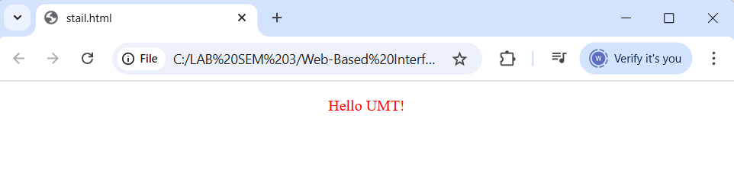

4.5 Recognize ID and Selector Class
stailID.html
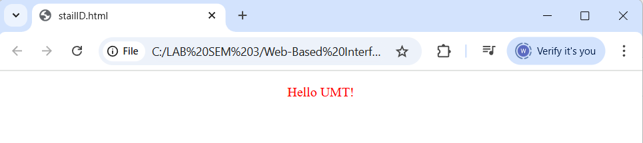

Class.html
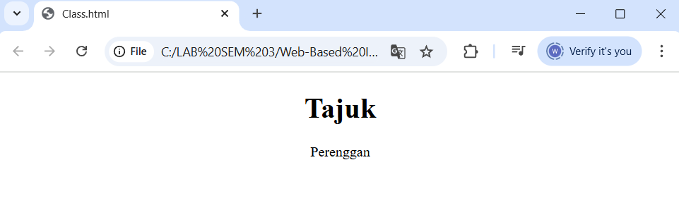

4.6 Navigation Bar using CSS
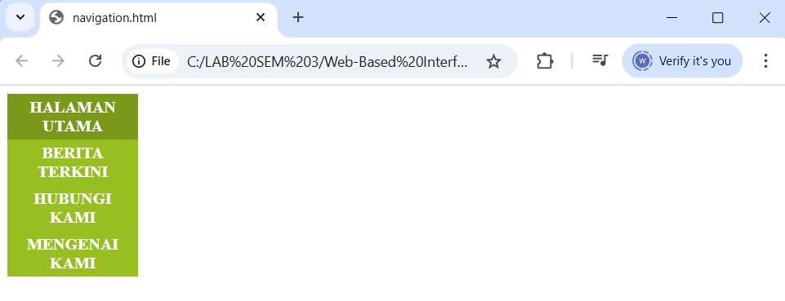

4.7 Recognizing Text Decoration
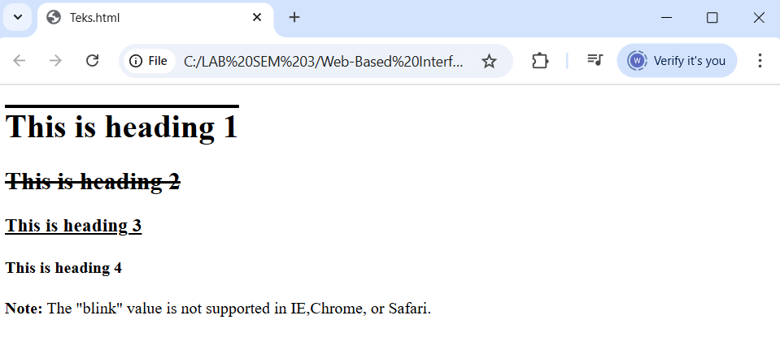

4.8 Recognizing Styling Link
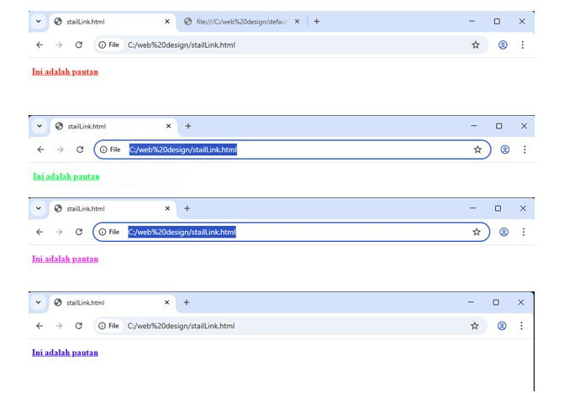

4.9 Lab Exercise 4
